CONFIDENTIAL CS/NOV 2026/MAT133

UNIVERSITI TEKNOLOGI MARA FINAL EXAMINATION

COURSE
COURSE CODE
EXAMINATION TIME
PRE CALCULUS
MAT133 NOVEMBER 2026
2 HOURS

INSTRUCTIONS TO CANDIDATES

- This question paper consists of 8 questions.

- Answer ALL questions in the Answer Booklet. Start each answer on a new page.

- Do not bring any material into the examination room unless permission is given by the invigilator .
- Please check to make sure that this examination pack consists of: i) the Question Paper
  - a one - page Append ix 1
  - an Answer Booklet - provided by the Faculty
  - a graph paper - provided by the Faculty

- Answer ALL questions in English.

/

DO NOT TURN THIS PAGE UNTIL YOU ARE TOLD TO DO SO

This examination paper consists of 8 printed pages

QUESTION 1
a) Given z₁ = -1 - 6i and z₂ = -1 + 3i, find z₁ + z₂ in the form a + bi.
(4 marks)
b) Given z₁ = -4 + 5i and z₂ = 5 - 3i, express z₁/z₂ in the form a + bi.
(5 marks)
c) Evaluate i^40 and simplify completely.
(3 marks)
d) Find the modulus and argument of z = 3 + 4i. Give the argument in degrees correct to one decimal place.
(5 marks)
QUESTION 2
a) Solve the simultaneous equations
4x - 2y = 10
x + 3y = -15.
(4 marks)
b) Solve the system of equations simultaneously:
-2x + y - 3z = 4
x - y + 3z = -1
-x - 2y - z = 0
(5 marks)
c) Solve the simultaneous equations
y = x² - 6
y = 8x - 21.
(5 marks)
QUESTION 3
a) Graph the system of inequalities below and shade the feasible region. State the vertices of the region.
x ≥ 0, y ≥ 0, 1x + 2y ≤ 6.
(5 marks)
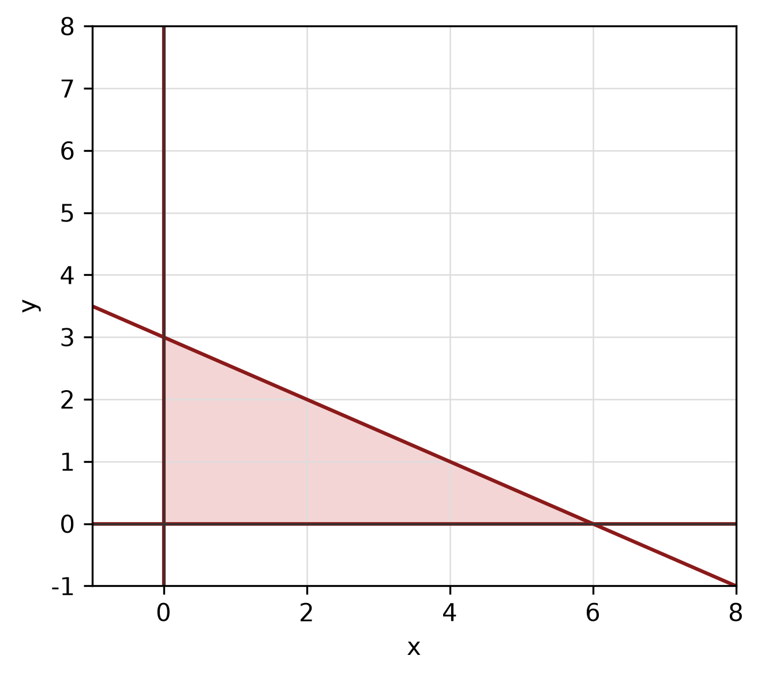
Figure: feasible region.
b) Write a system of inequalities that describes the shaded triangular region with vertices (0, 0), (3, 0) and (0, 8).
(5 marks)
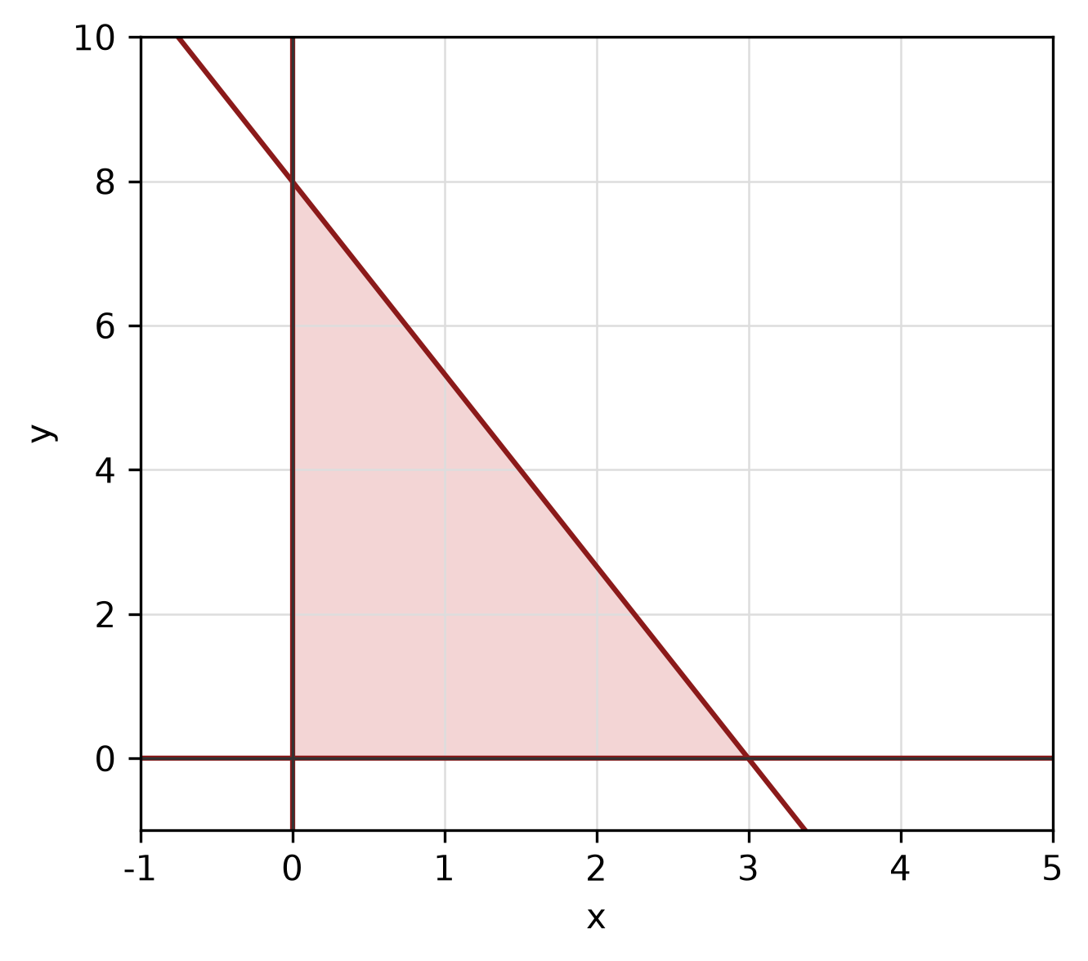
Figure: shaded triangular region.
QUESTION 4
a) Use long division to find the quotient and remainder when f(x) = -4x^3 + 4x² - 3x + 2 is divided by x - 1.
(5 marks)
b) Use synthetic division to divide f(x) = x^3 + 5x² - x + 5 by x + 3. State the quotient and remainder.
(5 marks)
c) Show that x - 4 is a factor of f(x) = 3x^3 - 9x² - 17x + 20 by using the factor theorem. Hence factorise f(x) completely.
(5 marks)
d) Use the remainder theorem to find the remainder when f(x) = 2x^3 + 2x² - 5x - 2 is divided by x + 3.
(3 marks)
e) Factorise f(x) = 3x^3 + 6x² - 27x - 54 completely.
(5 marks)
QUESTION 5
a) Solve the exponential equation 3^(4 - 3x) = 3^(-x - 2).
(5 marks)
b) Solve the logarithmic equation log_2(x) + log_2(x - 4) = 5.
(5 marks)
c) Express log_5(5) + log_5(5) as a single logarithm and evaluate it.
(3 marks)
QUESTION 6
a) Solve the trigonometric equation 2cos² x - 2cos x = 0 for 0° ≤ x < 360°.
(5 marks)
b) Prove the identity (1 + cos x)/sin x + sin x/(1 + cos x) = 2 csc x.
(5 marks)
c) Given sin A = 3/5 and A is in quadrant 1, find the exact values of cos A, tan A and sec A.
(4 marks)
d) For y = -3 sin(3x + 0) + -2, state the amplitude, period and phase shift, then sketch the graph for -180° ≤ x ≤ 180°.
(5 marks)
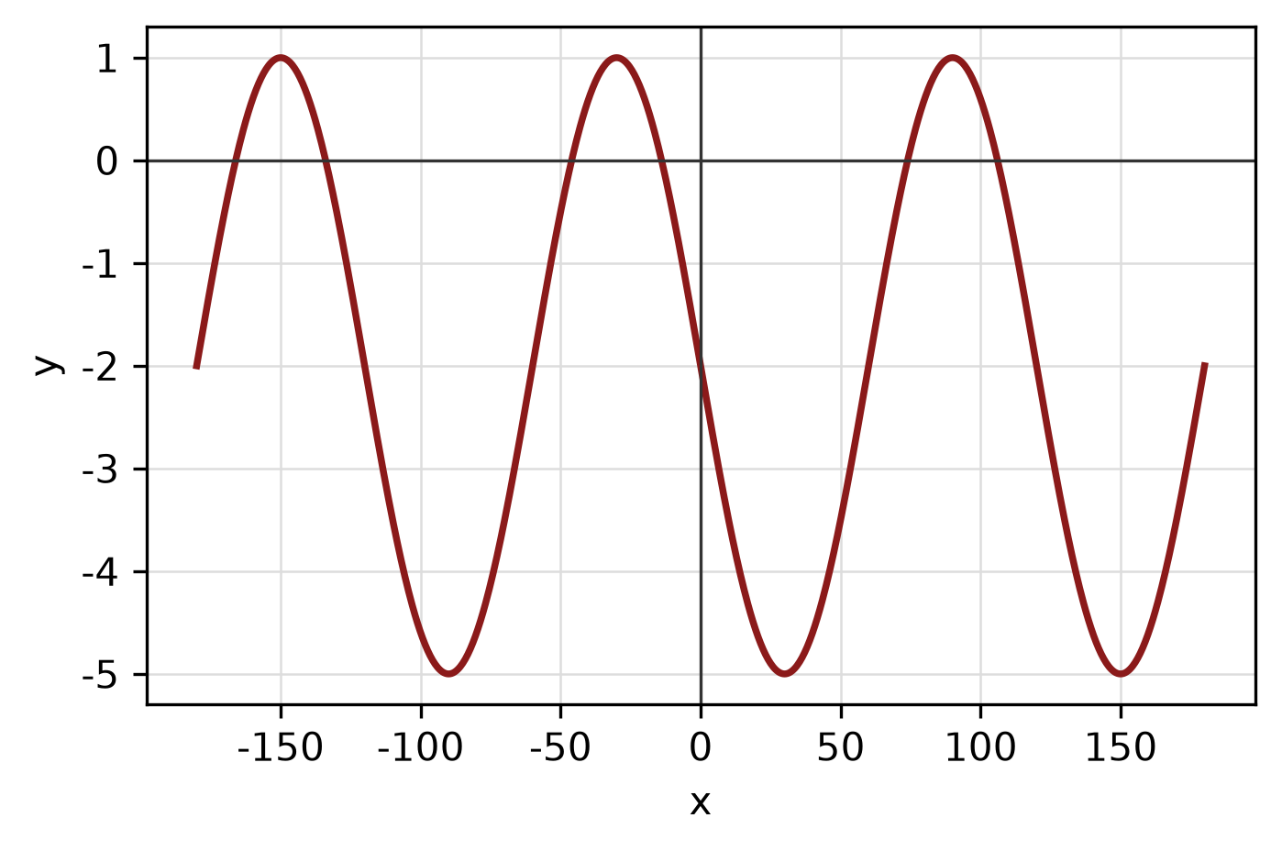
Figure: trigonometric graph.
e) Given sin A = 3/5 where A is in quadrant II and cos B = 4/5 where B is in quadrant IV, find sin 2A and cos(A + B).
(5 marks)
QUESTION 7
a) A circle has radius 9 cm. Find the length of the arc subtended by a central angle of 30°.
(4 marks)
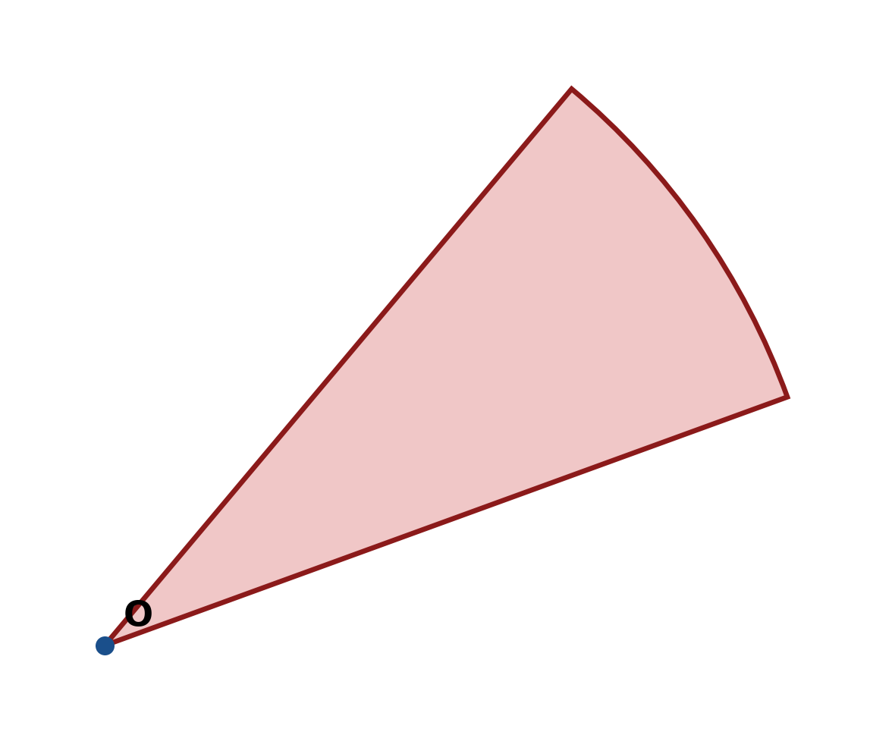
Figure: arc and sector.
b) Find the area of the sector of a circle with radius 5 cm and central angle 135°.
(4 marks)
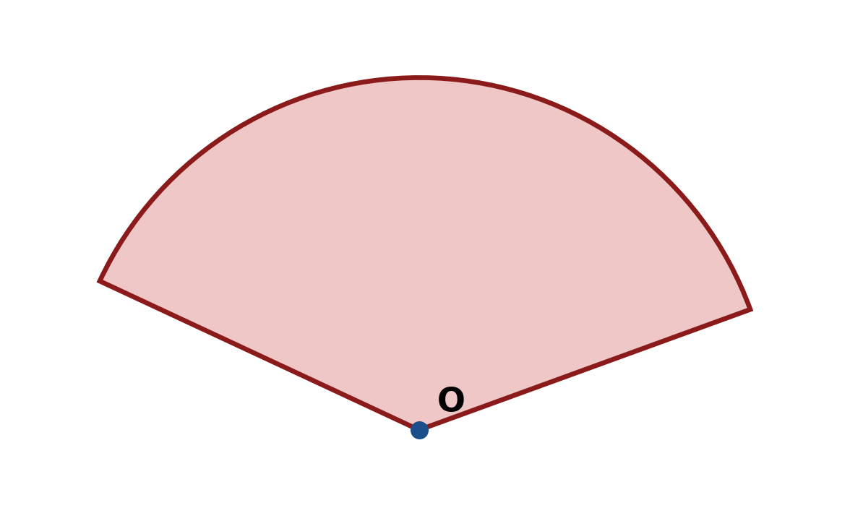
Figure: sector.
c) Find the perimeter of the sector with radius 12 cm and central angle 30°.
(4 marks)
Figure: sector.
d) Convert 45° to radians, and convert π radians to degrees.
(3 marks)
QUESTION 8
a) Solve the triangle with sides a = 8 cm, b = 15 cm and c = 17 cm. Find all three angles.
(5 marks)
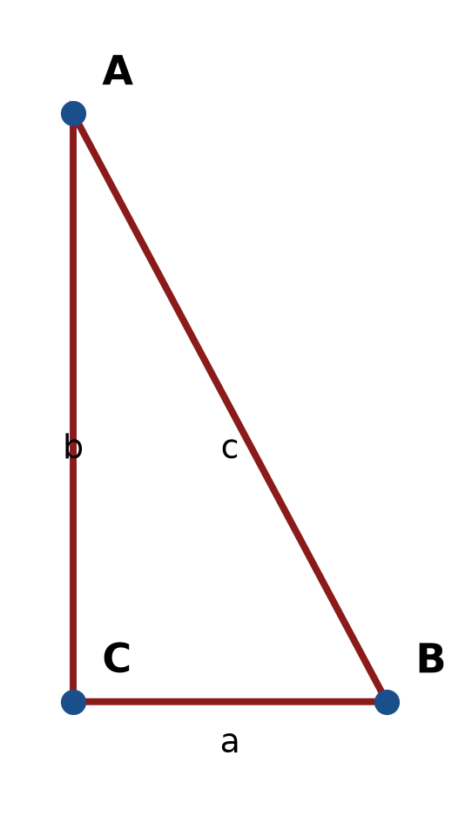
Figure: right triangle.
b) In triangle ABC, A = 30°, B = 45° and a = 11 cm. Use the sine rule to find b.
(4 marks)
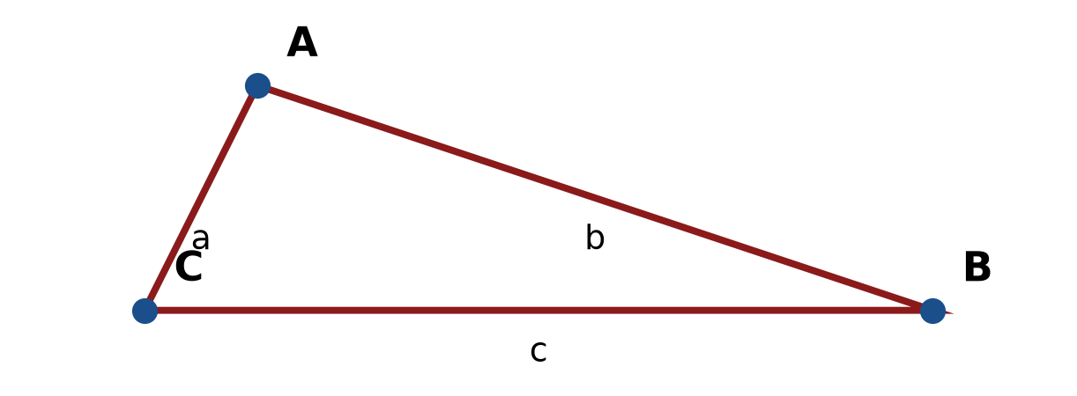
Figure: triangle ABC.
c) In triangle ABC, b = 5 cm, c = 6 cm and A = 120°. Use the cosine rule to find a.
(4 marks)
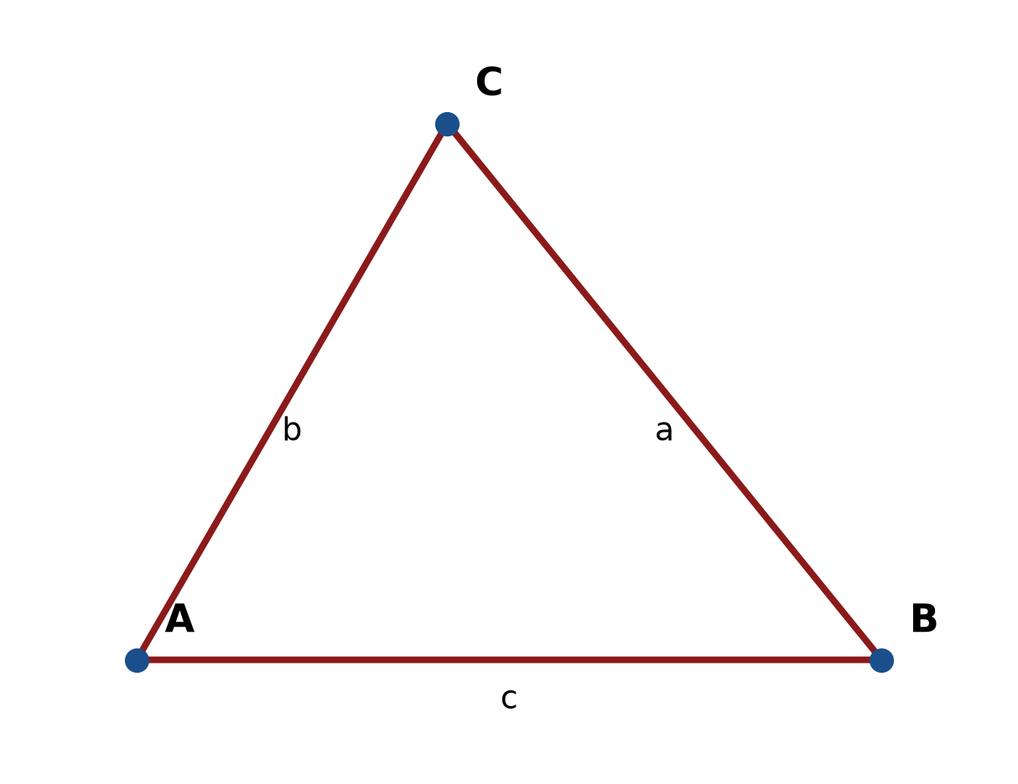
Figure: triangle ABC.
d) Find the area of triangle ABC with a = 15 cm, b = 6 cm and included angle C = 90°.
(4 marks)
e) A right triangle has legs 10 cm and 9 cm. A sector of radius 4 cm and angle 45° is cut from it. Find the area of the remaining shaded region.
(5 marks)
END OF QUESTION PAPER

APPENDIX 1
Formula sheet (as supplied with the paper).
sin² A + cos² A = 1 | tan² A + 1 = sec² A
sin(A + B) = sin A cos B + cos A sin B | tan 2A = 2 tan A / (1 − tan² A)
cos(A + B) = cos A cos B − sin A sin B | Arc length, s = rθ
tan(A − B) = (tan A − tan B) / (1 + tan A tan B) | Area of sector = ½r²θ
cos 2A = cos² A − sin² A | a / sin A = b / sin B = c / sin C
cos 2A = 1 − 2sin² A = 2cos² A − 1 | a² = b² + c² − 2bc cos A
sin 2A = 2 sin A cos A | Area of triangle = ½ab sin C

